
CSE106 Discrete Mathematics
Section: 06

Report of Mini Project
Representing a relation with n-dimensional relational matrix
by using C program

Submitted by: Group 06
Student ID | Student Name
2022-3-60-109 | Sheikh Sarafat Hossain
2022-3-60-192 | Rijia Parveen Raya
2022-3-60-128 | Syeda Sayma Sultana
2022-3-60-154 | MD. Shahmul Islam

Submitted To:
Dr. Mohammad Salah Uddin
Associate Professor
Department of Computer Science & Engineering
East West University

Date of Submission:
22.05.2023

Introduction:
A relational matrix is a mathematical representation of a relation between elements, and it can provide valuable insights into the properties and behaviors of the relation it represents. We focus on matrices with dimensions ranging from n=1 to n=300, allowing us to observe how the time complexity scales with the increasing size of the input. In this project, we aim to analyze the time complexity of a C program that generates and examines relational matrices.
Approach:
- Firstly, we made a C program to randomly generate a relational matrix represented by relation with dimensions n=1,3,50,100,150,200, 300.
- Secondly, the output will show the properties of the relation such as symmetric, Anti-Symmetric, transitive, and equivalence. The output will also show computational time in milliseconds (ms).
- The output will show whether the relation represents any function or not. The output will also show computational time in milliseconds (ms).
- After that, from the computational time of n=1,3,50,100,150,200, 300-dimensional matrixes, we used Microsoft Excel Worksheet to draw a line graph showing computational time vs. n dimension.
- Finally, we theoretically determine the computational time complexity of this program as a function of n. And compared it with the time complexity with steps 2 and 3.

The Output Of The Program:
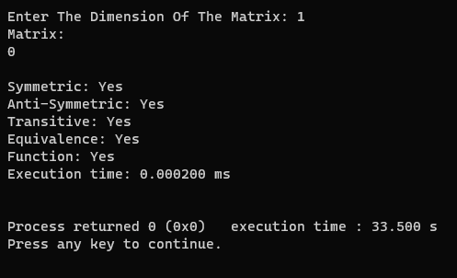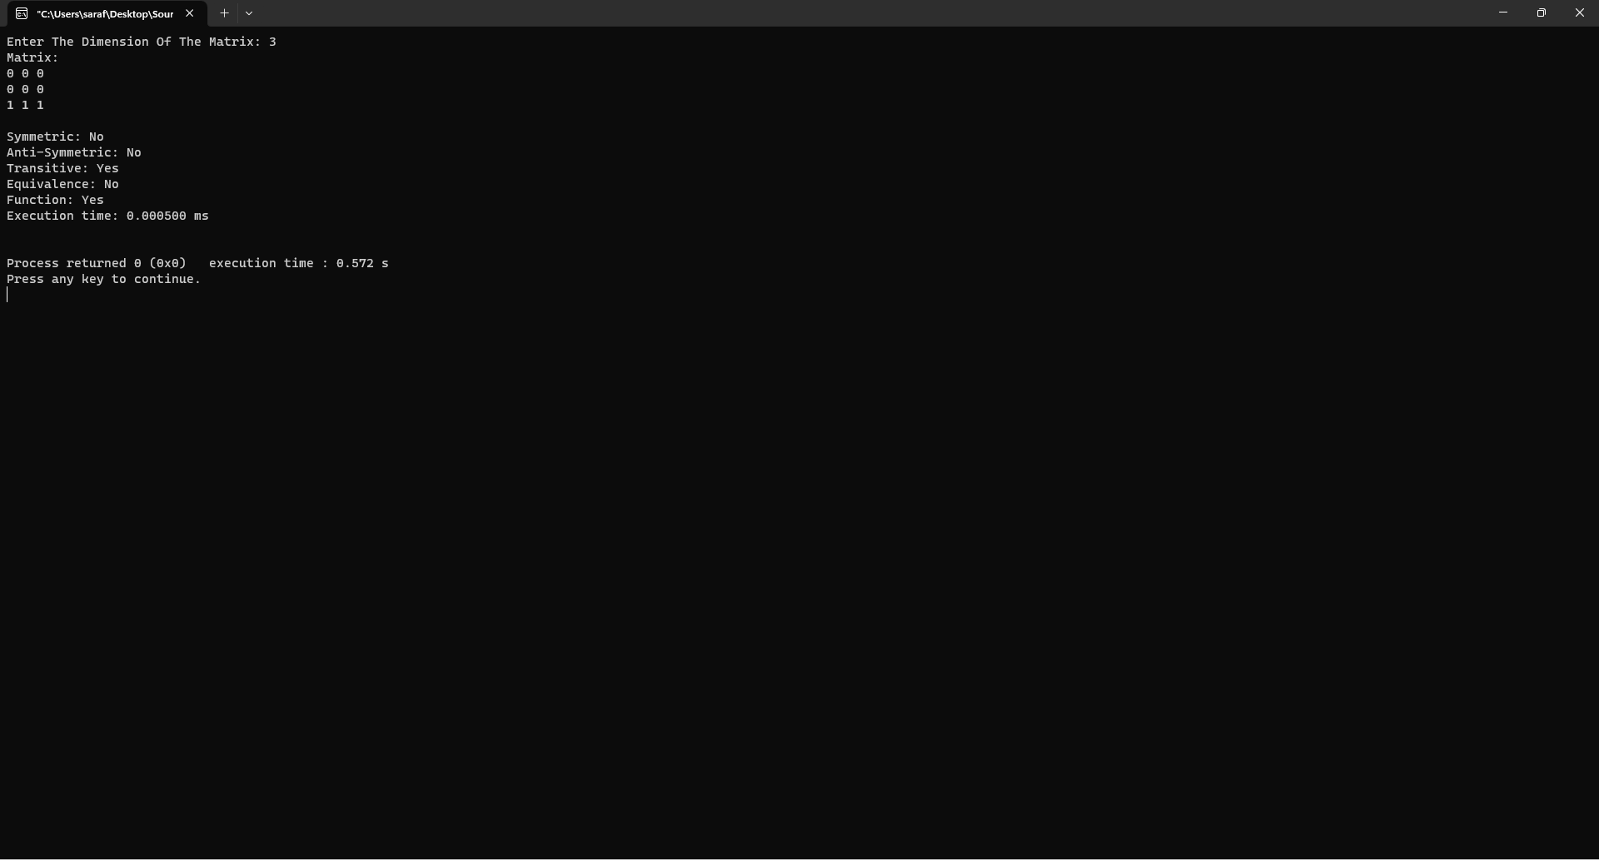
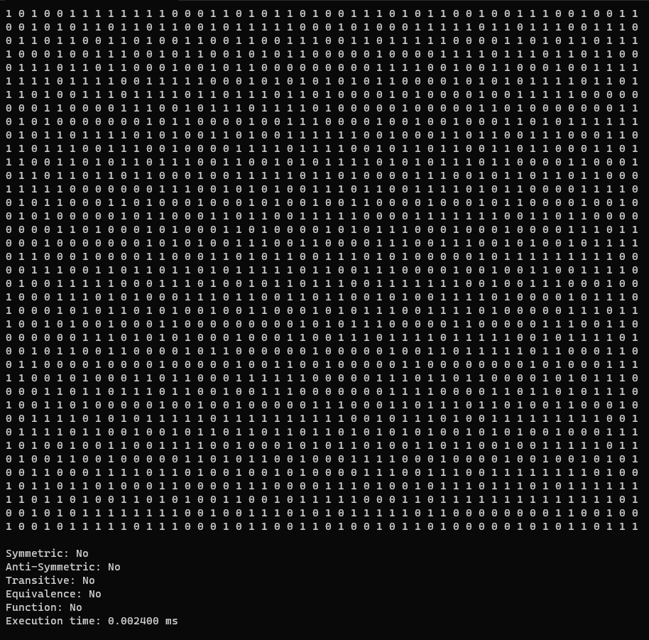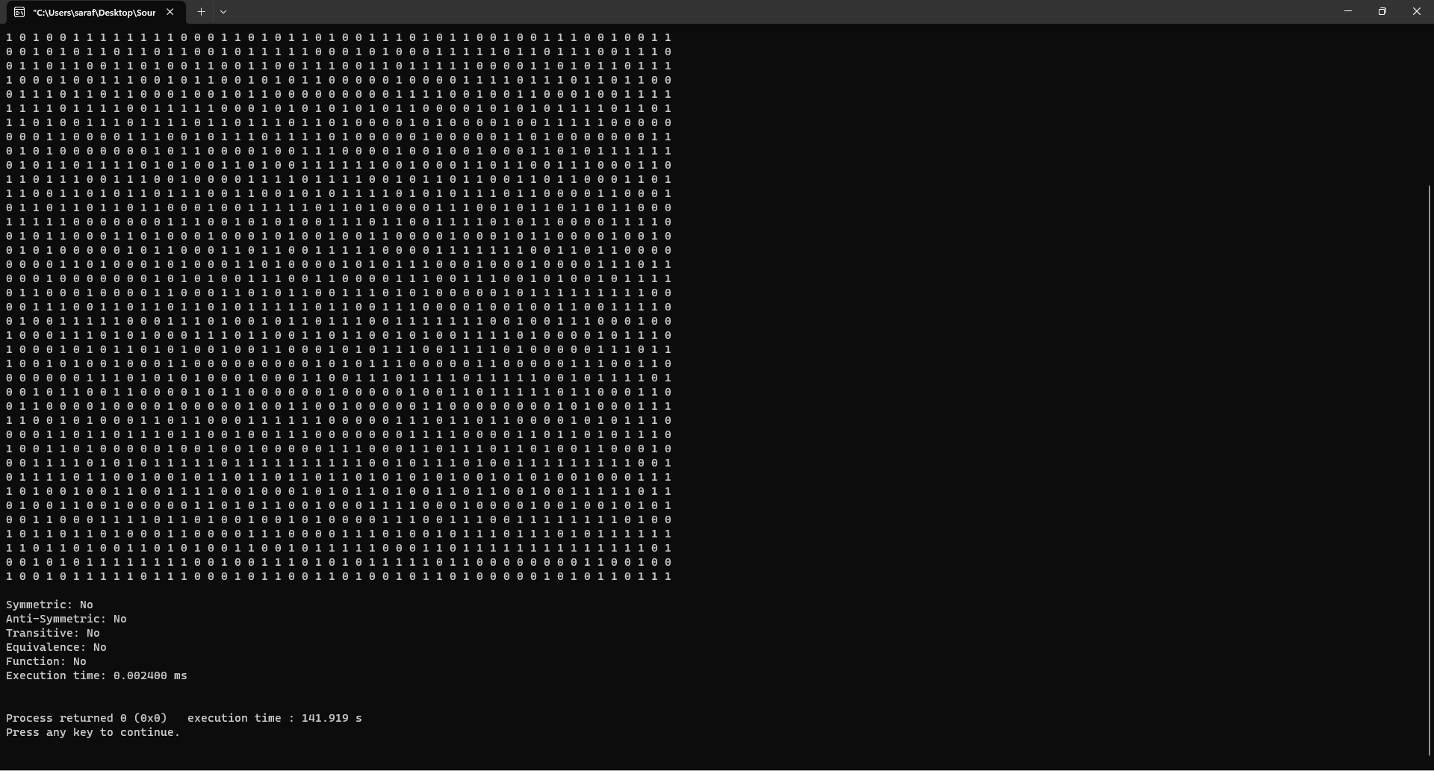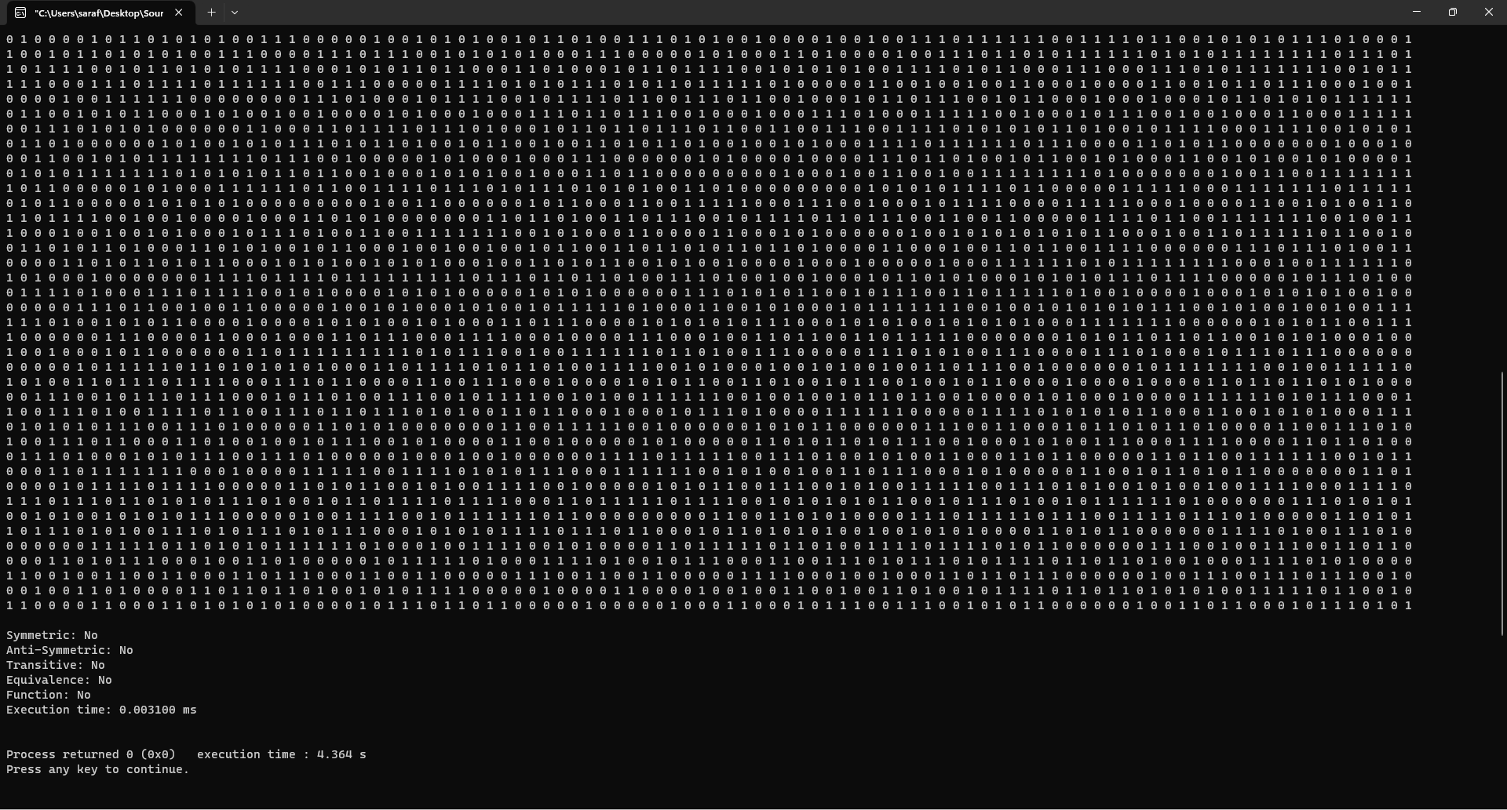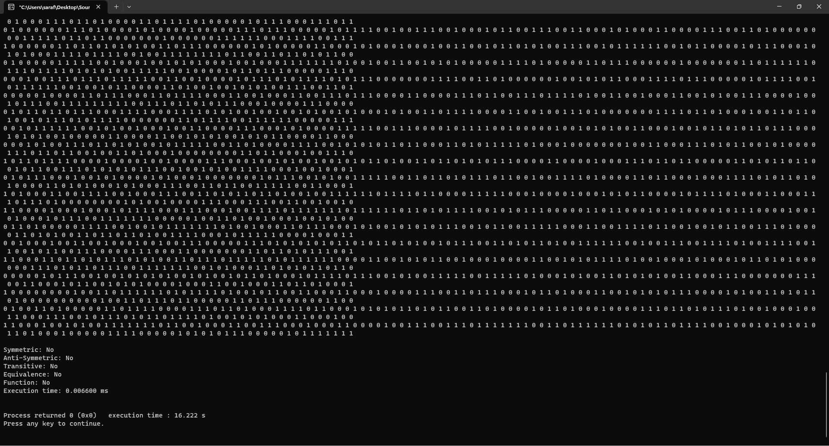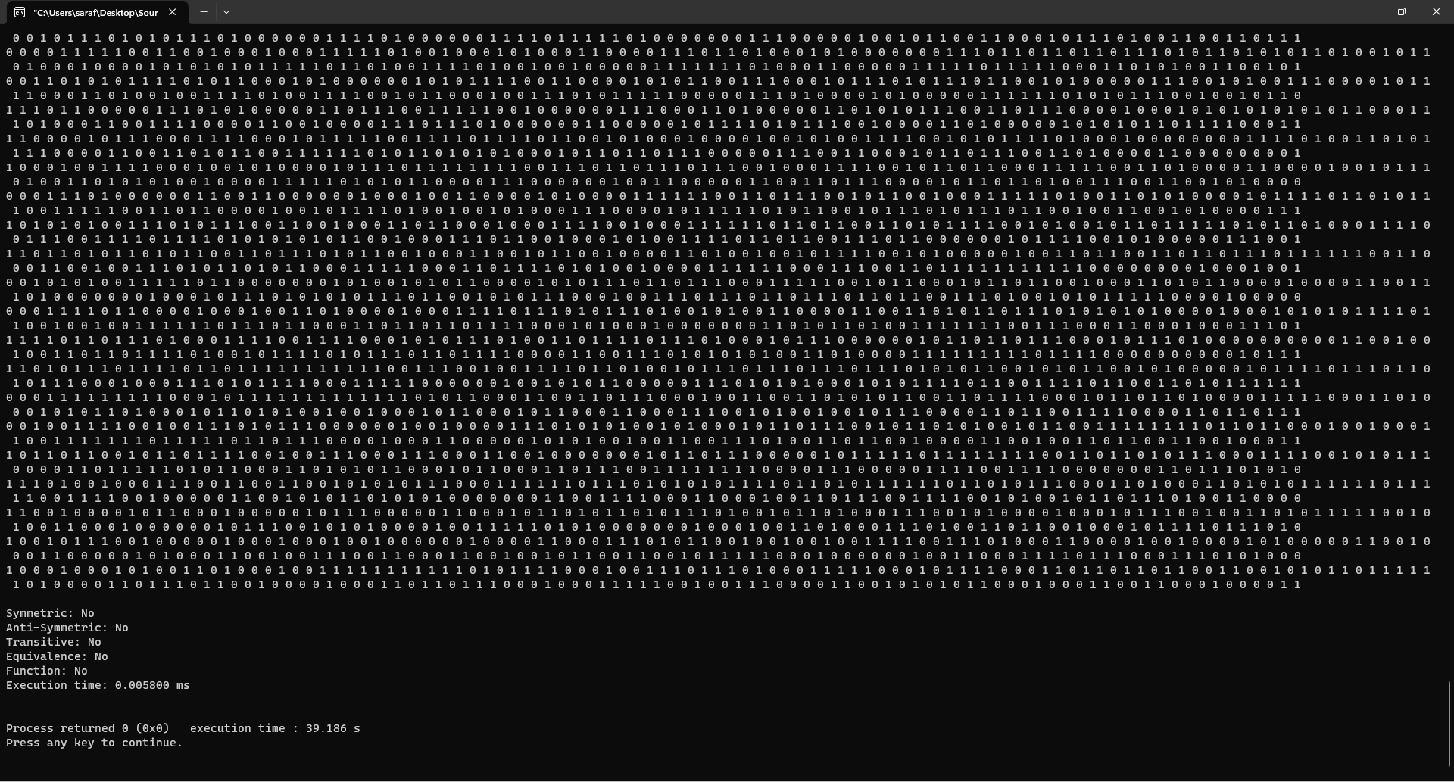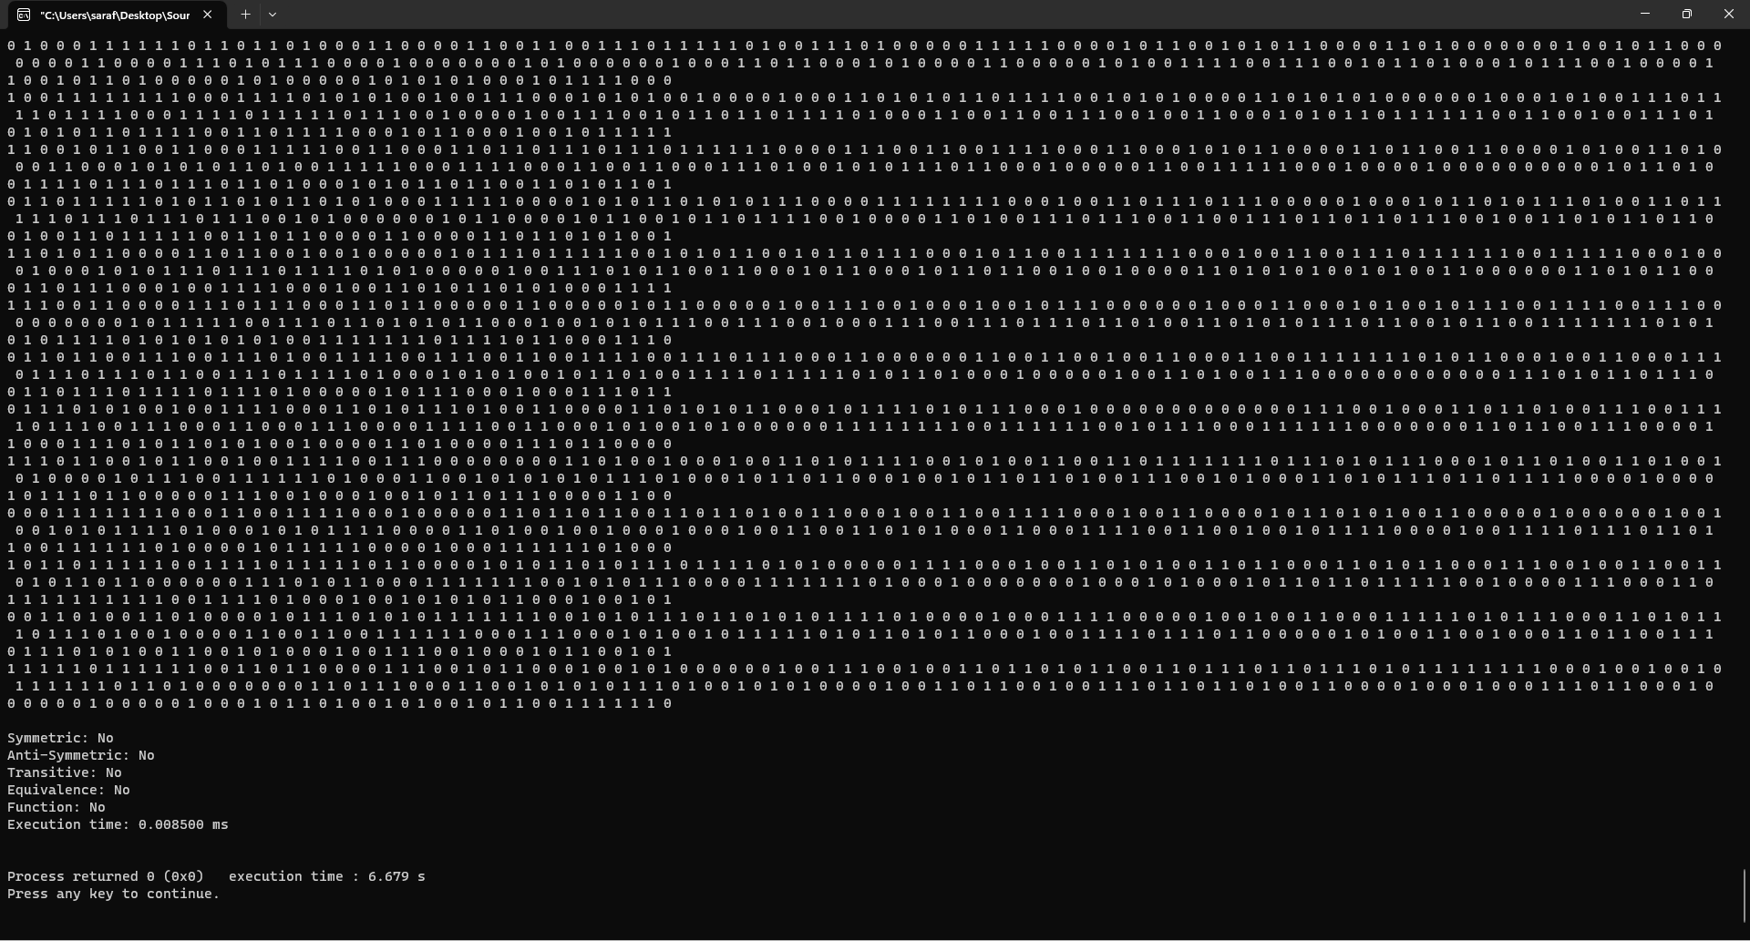
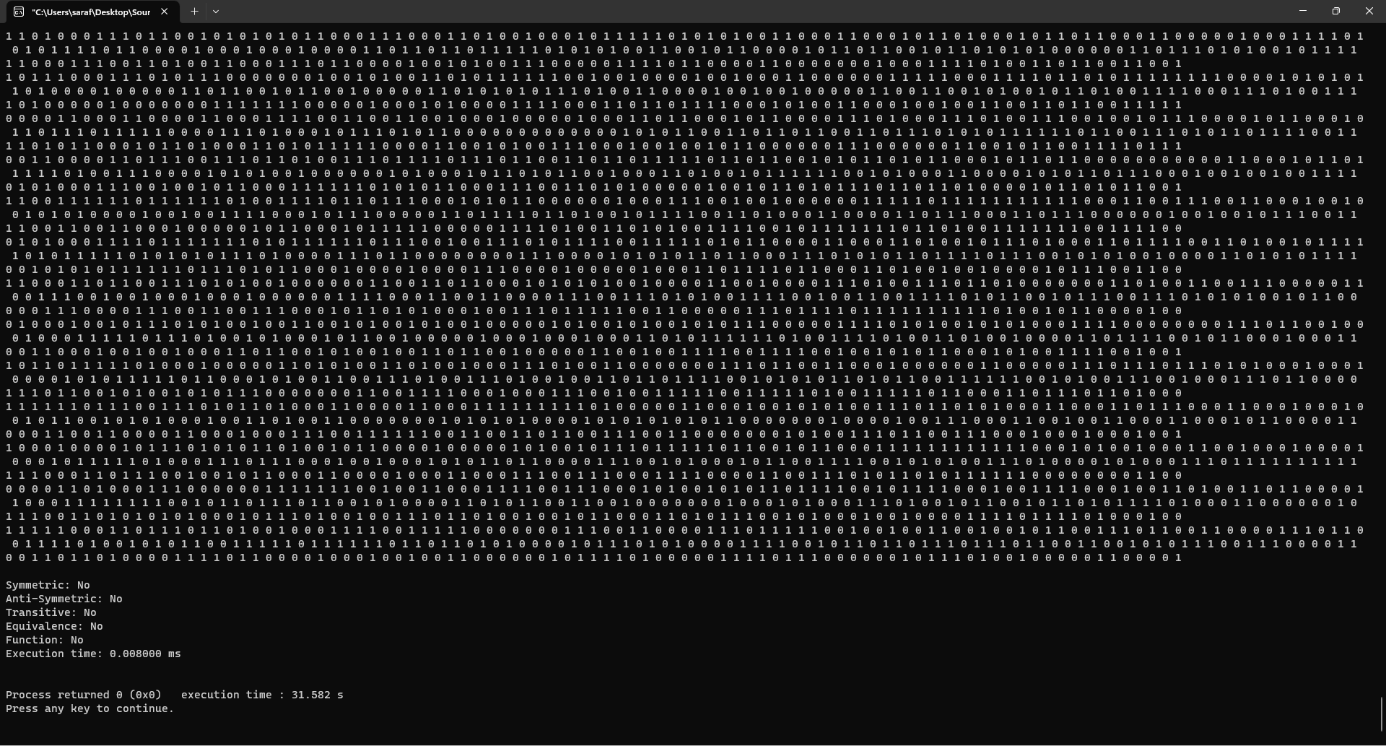

Time Complexity
Graph:

Theoretically:
- The nested loops for generating random values have a time complexity of O(n^2), where n is the dimension of the matrix.
- Checking symmetry: The nested loops for comparing matrix elements have a time complexity of O(n^2), as we compare each element with its corresponding element in the transpose.
- Checking anti-symmetry: The time complexity is O(n^2), similar to checking symmetry.
- Checking transitivity: The nested loops have a time complexity of O(n^3), as we check each element for the transitive property by comparing it with other elements in the matrix.
- Checking equivalence: It depends on the time complexities of symmetry and transitivity, so the time complexity is O(n^2 + n^3), which simplifies to O(n^3).
- Checking function: The nested loops have a time complexity of O(n^2), as we count the number of "1" entries in each row.
Overall, the code's time complexity is dominated by the operations for checking transitivity, which is O(n^3)

